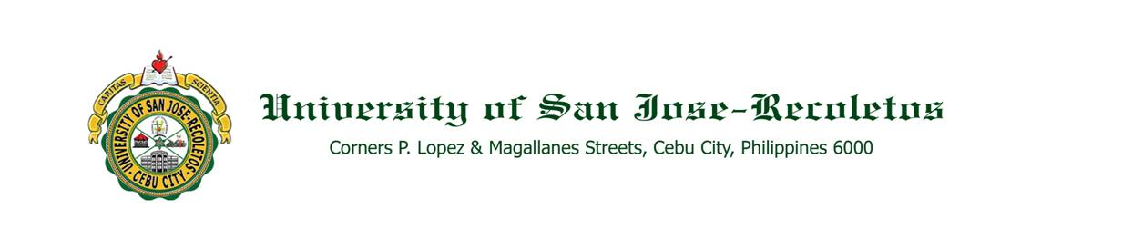

**TO : ALL CONCERNED August 17, 2020**

**SUBJECT : APPOINTMENTS of COLLEGE CHAIRS**

The School Board is pleased to inform you of these appointments of college chairs for Academic Year 2020-2021.

DJC - DR. MILA MAE A. CABALLERO

DSSP - MR. GALLARDO E. GULAY

DMS - MR. MARK IAN C. ANDRES

DPLIS - MR. LEO M. ANTIPORTA

DLL - DR. SHERILYN L. SALVE

CICCT - DR. JOVELYN C. CUIZON

COE - MR. IONELL JAY R. TEROGO

PE - MR. MONTANO L. TAPANAN JR.

SPED - MS. EVA MARIA A. DIVINAGRACIA

ACCTG. & FINANCE - DR. CEDRIC VAL R. NARANJO

BUS. & ENTREP - MRS. YOUNGLIN J. HITUTUANE

THMD - MR. REO Y. YAMUTA

MKTG. & HRDM - DR. AVA-LOU C. PEREZ

CRE - DR. JOJIT M. FORONDA

ME - ENGR. JEREMIAH A.BADANA

ECE - ENGR. ANTHONY N. JAGURES

EE - ENGR. ROEL N. MILITAR

CE - ENGR. ELVIRA D. SALES

IE - ENGR. NANETTE T. SALAZAR

CompE - ENGR. EUTEQUIO III ZANTE L. PALERMO

DEMSRP - ENGR. CRIS VINCENT P. MANLUNAS

Please extend to them you usual kind support and cooperation so that they can effectively carry out their tasks, duties and responsibilities.

Thank you and God bless. Adelante!

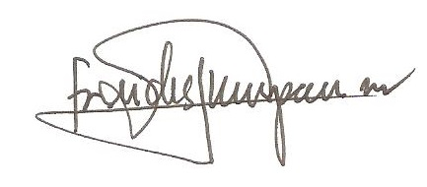

REV. FR. CRISTOPHER C. MASPARA, OAR

President

/bvs